**A1_testing.doc**

**URL links**

<https://jupiter.csit.rmit.edu.au/~s4019427/A1_August_s4019427/index.html>

<https://jupiter.csit.rmit.edu.au/~s4019427/A1_August_s4019427/contactus.html>

**Tested Date**: 10/08/2023

**Tested by:** August Oo aka Byuelar Oo s4019427

**Browsers**: Google Chrome, Microsoft Edge

**Tested Detail:**

Navigate from the Home page to the Contact Us page.

Test of accessibility link and *Read More* links at the home page articles.

Fill out the "Contact Us" form and submit an enquiry.

**Results:**

The website navigation and accessibility features were tested on Google Chrome and Microsoft Edge. All the functionality on both pages, Home and Contact Us, worked smoothly. Browser compatibility on both browsers worked without issues.

**Google Chrome**

index.html

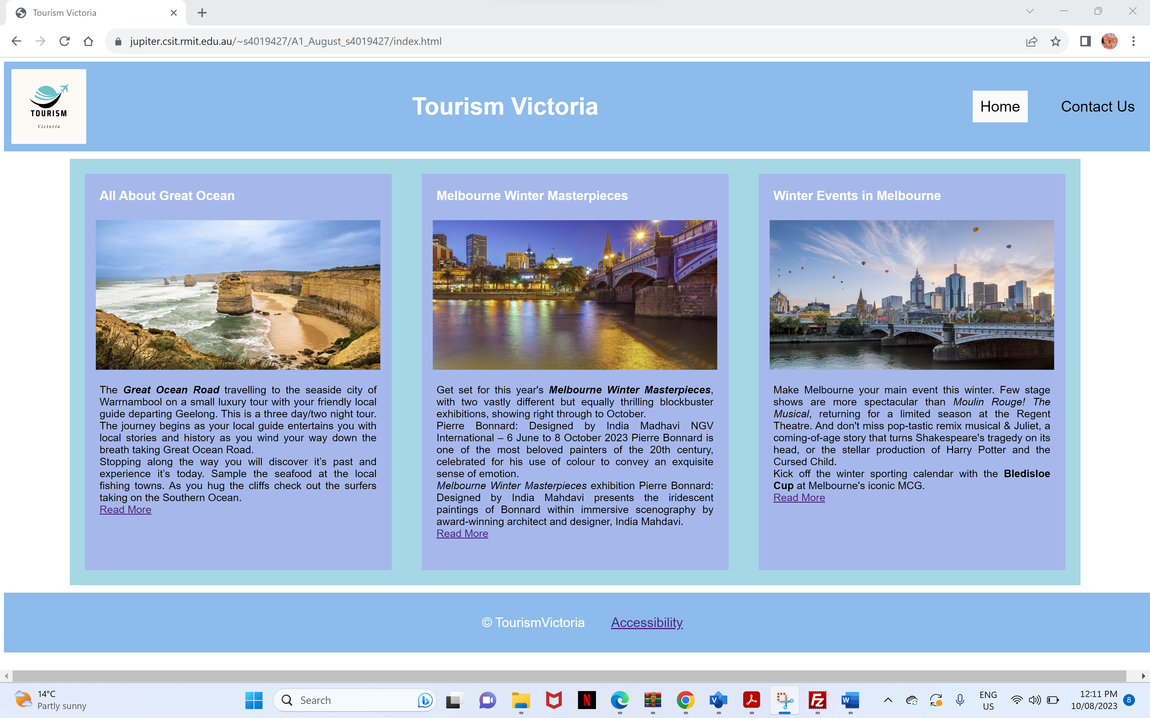

contactus.html

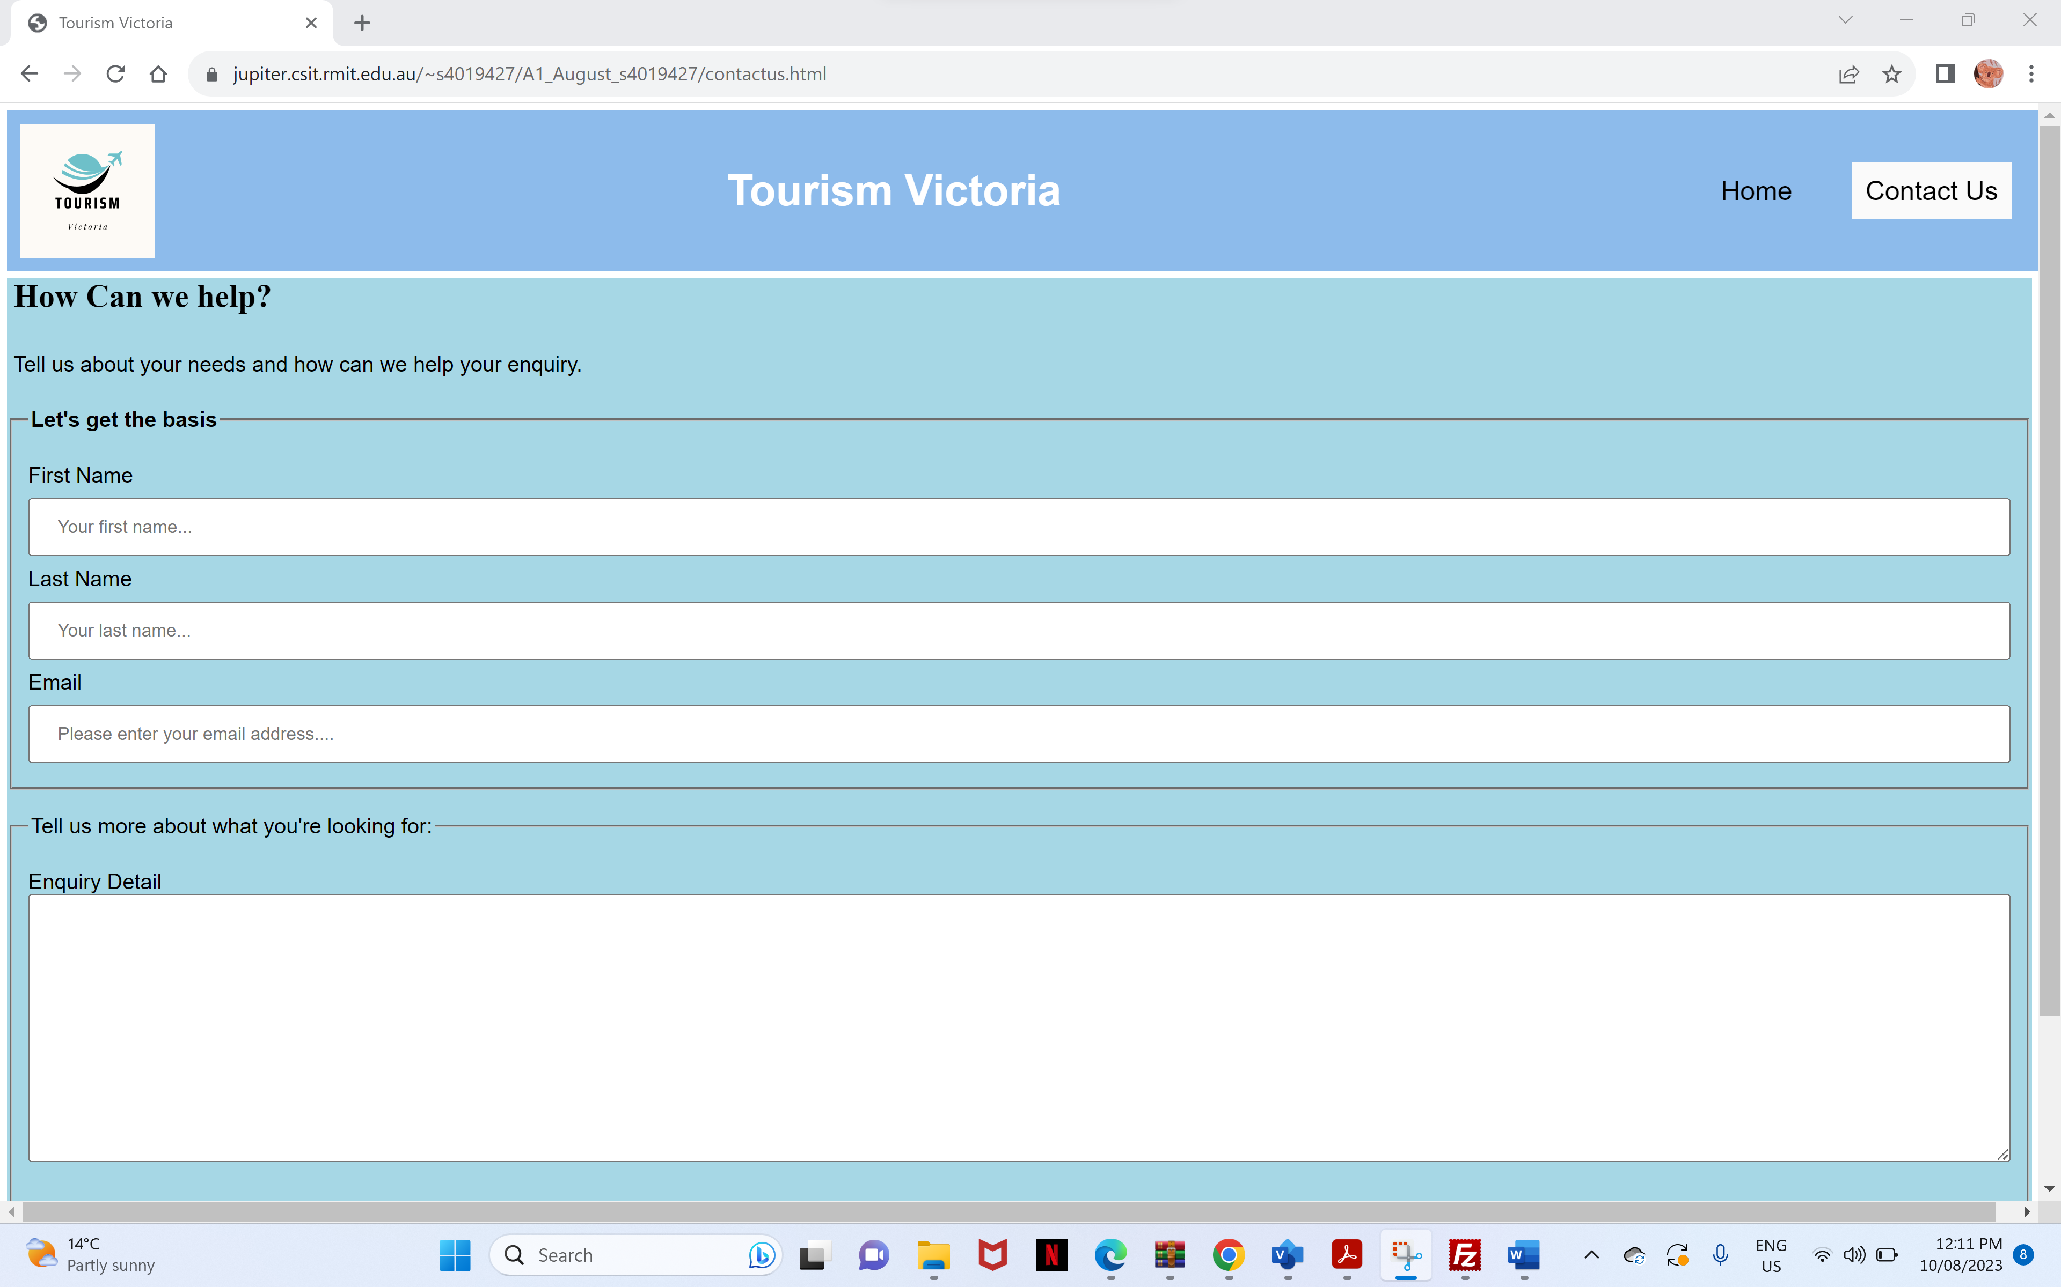

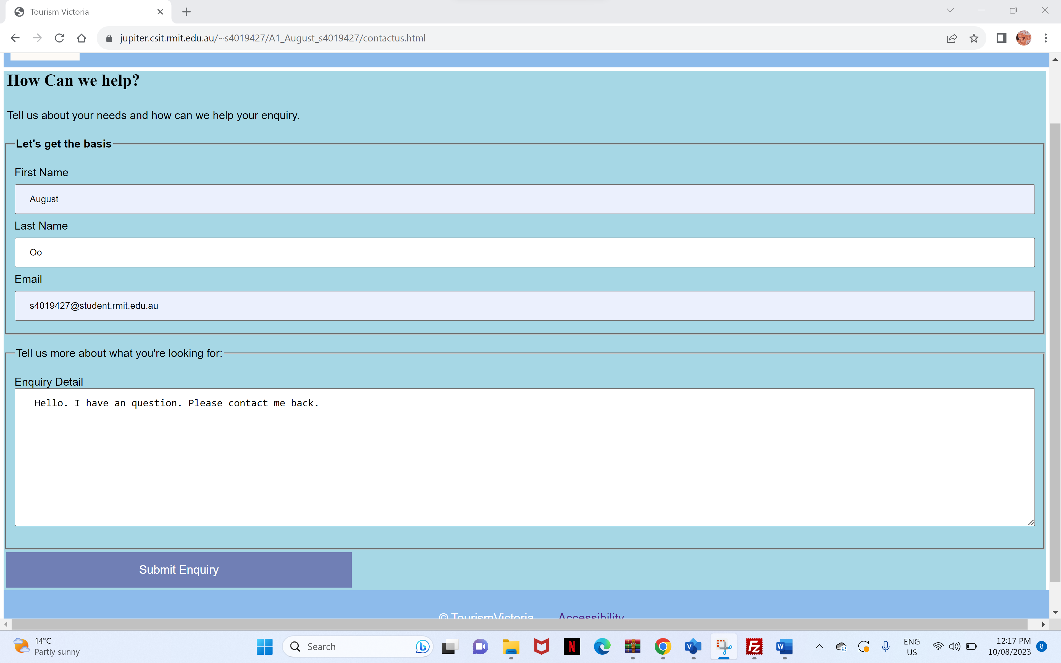

**Microsoft Edge**

index.html

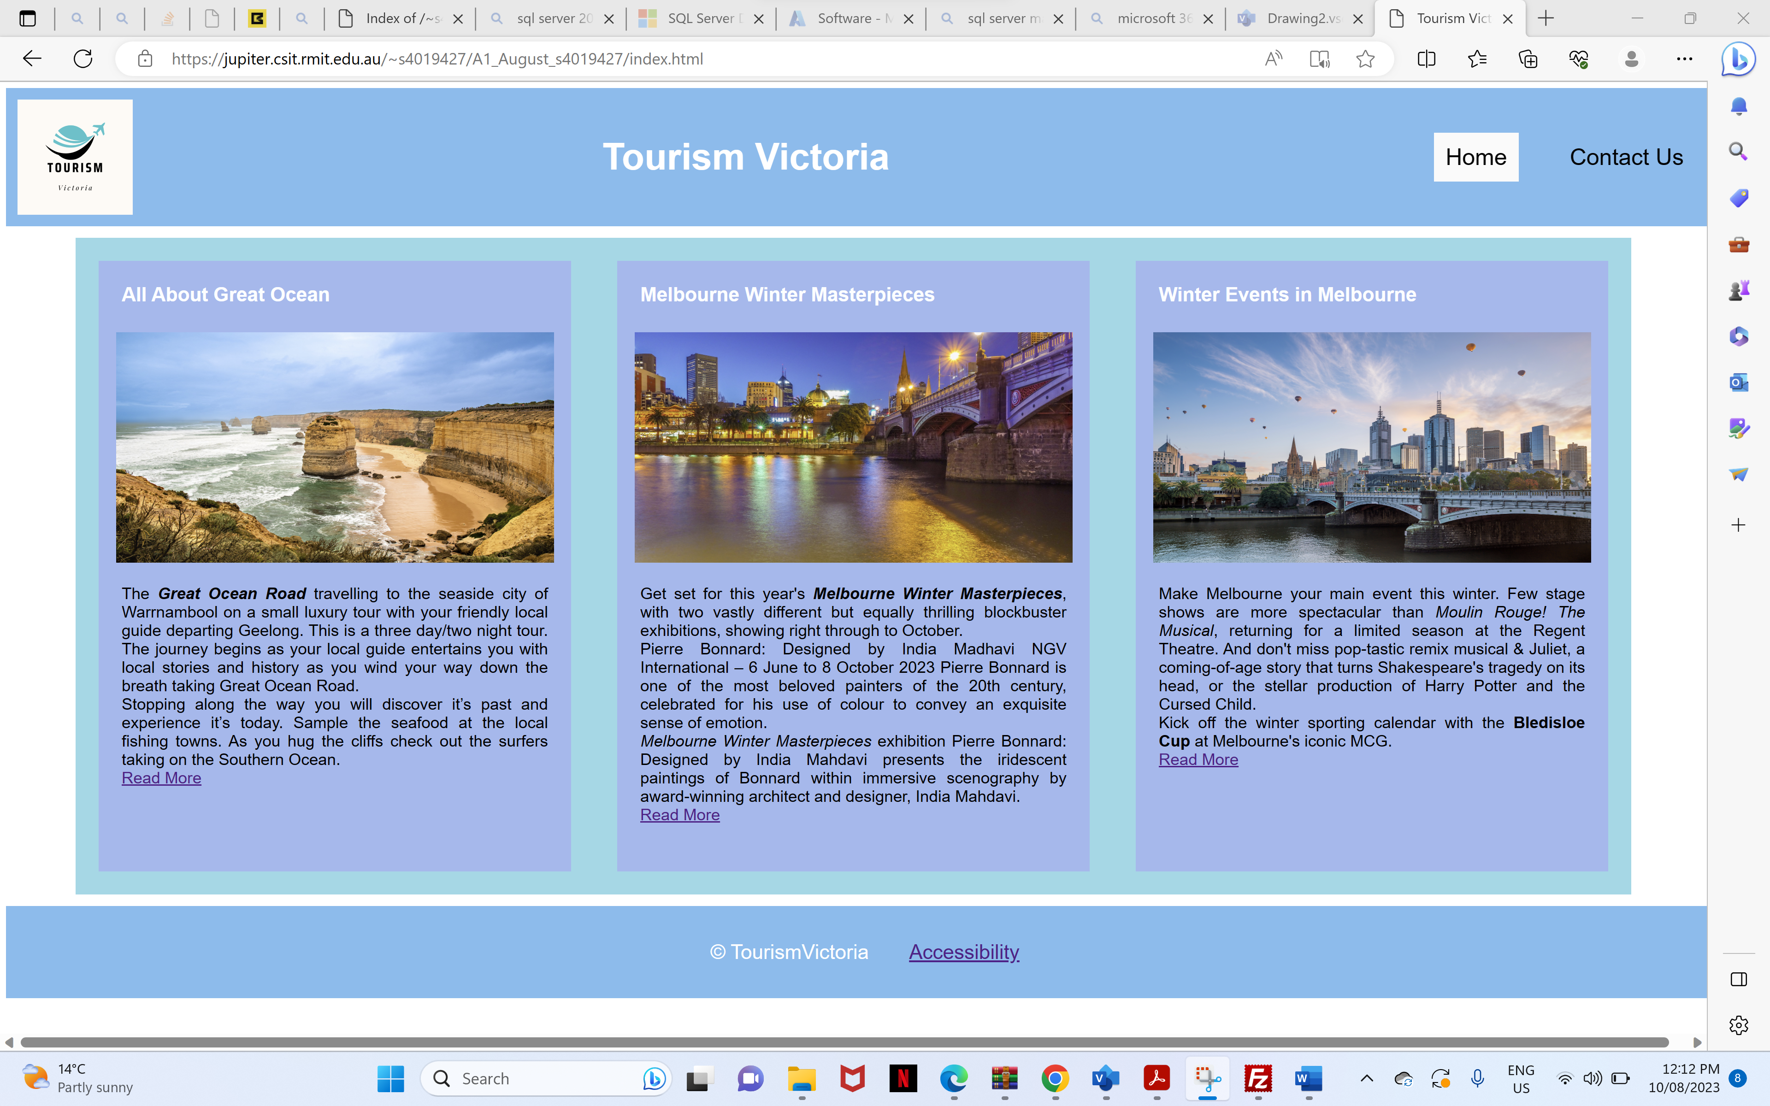

contactus.html

